Group 6

Belgium campus

Project design Aloe Ferox

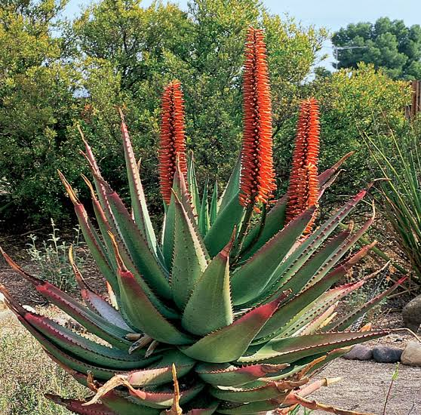

Table of Contents

System Overview 2

System Architecture 2

Functional Description 2

Design Constraints 2

Detailed Design 2

Component Design 2

Interface Design 2

Data Design 2

User Interface Design 2

UI Layout 2

User Experience 2

Performance and Scalability 2

Performance Requirements 2

Scalability 2

Security Design 3

Security Requirements 3

Compliance 3

Testing and Validation 3

Test Plan 3

Validation Criteria 3

Deployment and Maintenance 3

Deployment Plan 3

Maintenance Plan 3

# 

# System Overview

## System Architecture

## Functional Description

## Design Constraints

# Detailed Design

## Component Design

## Interface Design

## Data Design

# User Interface Design

## UI Layout

## User Experience

# Performance and Scalability

## Performance Requirements

## Scalability

# Security Design

## Security Requirements

## Compliance

# Testing and Validation

## Test Plan

## Validation Criteria

# Deployment and Maintenance

## Deployment Plan

## Maintenance Plan